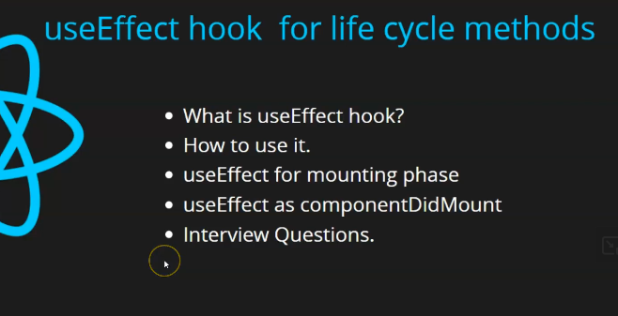

Now we are talking about useEffect Hooks which is used in functional component as a lifecycle method you can ask that like there are manty lifecycle methods so for all there are different hooks or that useEffect hook is the only one. yes for all life cycle there is specific hook that is useEffect. Inside it we pass some condition or parameters and we by manipulating it we use it for all lifecycle methods

Now next question you will ask that are we studying lifecycle method or useEffect hook. You don’t have to be confused here Gangadhar hi Shakti man hain means whenever inside functional component we need to use lifecycle methods you need to use useEffect and you cannot use it inside class component Inside class method you need to type methods for reach lifecycle but as the teacher told in last lesson or second last lesson that class component are not used often we use only functional component So we will not focus there we will focus only on useEffect and we are going to see in next upcoming lessons that how we can use it by different ways. How to use it just for mounting , How to use it for updation and to use it for unmounting we will see this in upcoming lesson Now lets start with points as shown in upper screenshot at the top

At first teacher will tell us that What is useEffect Hooks Tracher has already told us about it and again teacher will explain it because it can be confusing for beginners and second point is that we will see How to use it. Teacher will tell it practically by writing a code. This point is that we will see it how to use it for mounting phase and How to use it like componentdidMount ( lifecyle method(maybe not) in class component ) . It is a very important point it is often asked in Interview when this will come when we will be doing coding then teacher will tell it and at last we will cover some interview question So start with first question that is what is useEffect Hooks.

2:00